CWPPRA

Coastal Wetlands Planning, Protection and Restoration Act

Task Force Members:

U.S. Army Corps of Engineers
New Orleans District
Post Office Box 60267
New Orleans, LA 70160-0267
504/862-2201
•
U.S. Environmental Protection Agency
1445 Ross Avenue
Dallas, TX 75202
225/389-0735
•
U.S. Department of Commerce
National Marine Fisheries Service
1315 East West Highway
Silver Spring, MD 20910
301/713-2370
•
U.S. Department of Interior
Fish and Wildlife Service
646 Cajundome Boulevard
Suite 400
Lafayette, LA 70506
337/291-3100
•
U.S. Department of Agriculture
Natural Resources Conservation
Service
3737 Government Street
Alexandria, LA 71302
318/473-7762
•
State of Louisiana
Governor's Office of Coastal Activities
Post Office Box 94396
Baton Rouge, LA 70804-9396
225/342-3968
•
LA Department of Natural Resources
Office of Coastal Restoration
and Management
225/342-7308

FOR RELEASE: Friday, April 9, 2010
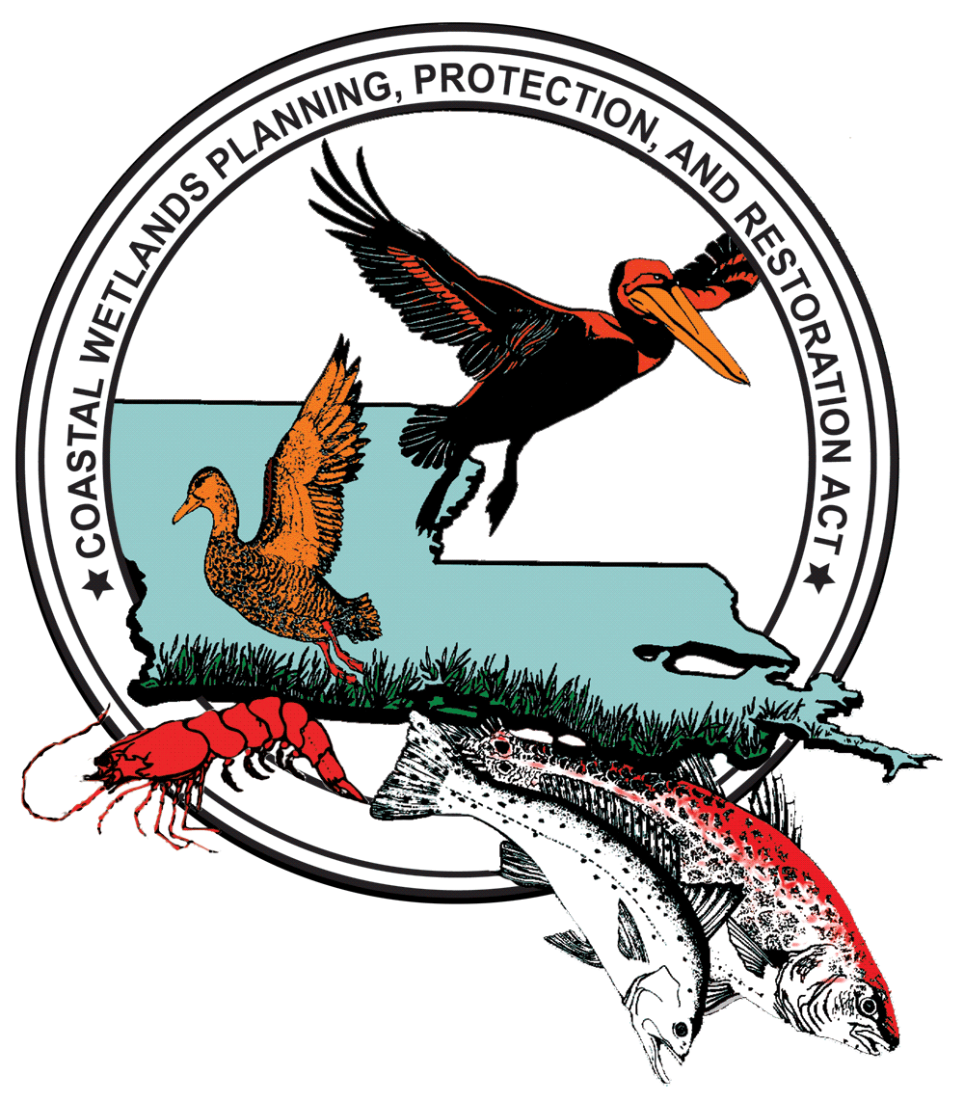
www.lacoast.gov

Contact: André Williams
Media Specialist
IAP World Services/USGS National Wetlands Research Center
Office: 337-266-8542 / Cell: 337-296-5095 / Fax: 337-266-8616
E-mail: WilliamsA@usgs.gov

Southeast Louisiana Celebrates
20 Years of Coastal Restoration Progress
The Coastal Wetlands Planning Protection and Restoration Task Force celebrated 20 years of restoring and protecting Southeast Louisiana’s coastal wetlands. The ceremony was held Thursday, April 8, 2010 at Woodland Plantation in West Pointe a La Hache, and included participants from the five federal managing agencies, along with local landowners and state and local dignitaries.

The ceremony marked the 20 year anniversary of the Coastal Wetlands Planning, Protection and Restoration Act (CWPPRA), and highlighted 15 projects in the Southeast region. Attendants participating in the ceremony were able to tour the Bayou Dupont Mississippi River Sediment Delivery (BA-39) and the Barataria Basin Landbridge (BA-36 / BA-27) projects. Several coastal restoration advocates were also recognized for their dedication and commitment to the CWPPRA program over the past 20 years.

“CWPPRA has been the backbone of coastal restoration efforts in Louisiana for the last 20 years and will continue to play a very important role as we move forward in constructing more and larger ecosystem restoration projects with our federal partners into the future,” said Steve Mathies, executive director of the Louisiana Office of Coastal Protection and Restoration. “The innovation and technology developed through the CWPPRA program and the lessons we have learned by putting these vital projects on the ground and observing how our coastal marshes, lakes, bays and barrier islands respond is making it possible for us to design even larger projects so we can build upon the foundation laid over the past two decades.”

CWPPRA was enacted in 1990 under former U.S. Senators John Breaux and J. Bennett Johnston. Since its inception, the federal Act has approved 148 restoration projects, benefiting over 110,000 acres of land. CWPPRA represents a collaborative effort, and is managed by a Task Force comprised of the State of Louisiana Governor’s Office of Coastal Activities, U.S. Army Corps of Engineers, U.S. Environmental Protection Agency, U.S. Fish and Wildlife Service, U.S. Natural Resources Conservation Service, and the U.S. National Marine Fisheries Service.
-30-
For more information on CWPPRA’s restoration projects, or to download press photos, visit: www.LaCoast.gov

