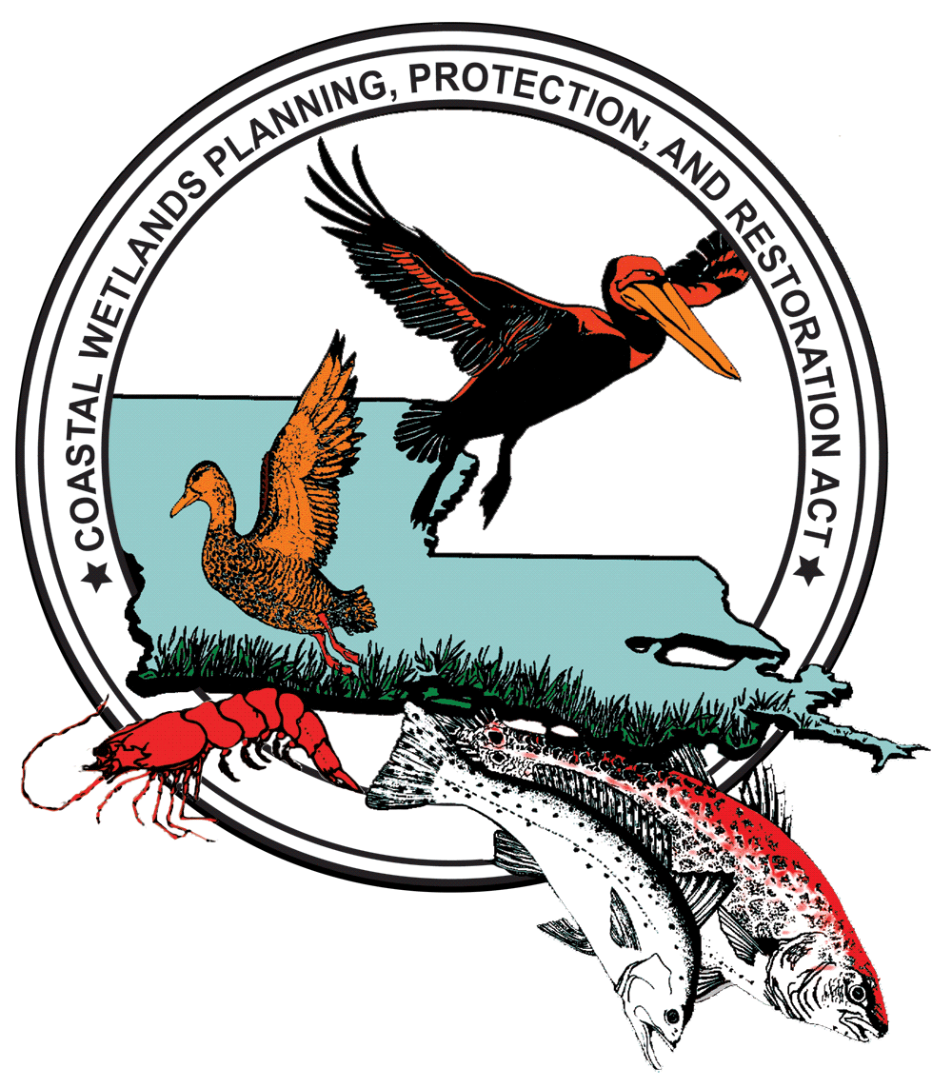
CWPPRA
Coastal Wetlands Planning,
Protection and Restoration Act

BACKGROUNDER / FACTS SHEETS

About CWPPRA:

Louisiana is blessed with an abundance of natural resources. Approximately 40 percent of the coastal wetlands of the lower 48 states are located in Louisiana.
This fragile environment is disappearing at an alarming rate. Louisiana has lost up to 40 square miles of marsh a year for several decades - that's 80 percent of the nation's annual coastal wetland loss. If the current rate of loss is not slowed, by the year 2040 an additional 800,000 acres of wetlands will disappear, and the Louisiana shoreline will advance inland as much as 33 miles in some areas.
To address the need for immediate action, Congress passed the Coastal Wetlands Planning, Protection and Restoration Act (CWPPRA) in 1990. Sponsored by former U.S. Senators John Breaux and J. Bennett Johnston of Louisiana, this legislation funds a multi-faceted coastal rehabilitation program that is managed by a task force of five federal agencies and the Louisiana state government. The goal of CWPPRA is to fund coastal restoration projects that re-establish degraded wetlands and restore natural processes where possible.
The CWPPRA Task Force annually develops a list of high-priority projects to be constructed. To date, sixteen such priority lists have been formulated. The projects funded by CWPPRA all focus on marsh creation, restoration, protection or enhancement.
Since 1990, CWPPRA has completed or initiated 148 restoration projects in coastal Louisiana. During the 20-year life span of each project, over 110,000 acres of land are expected to be created or protected, and an additional 320,000 acres enhanced.
Although current funding levels do not support all the necessary restoration required of a sustainable ecosystem, CWPPRA continues to address immediate restoration needs while establishing a foundation of strong science, public participation, and agency cooperation that will serve as the cornerstone of future programs.
For more information on CWPPRA, visit: www.LaCoast.gov
###

